**FACULTY OF ENGINEERING, DESIGN AND TECHNOLOGY**

DEPARTMENT OF COMPUTING AND TECHNOLOGY

EASTER 2024 SEMESTER PROJECT-BASED EXAM REPORT

PROGRAM: BSc. Data Science and Analytics

COURSE: Web Application Development

COURSE LECTURER: Mr Kenneth Musasizi

PROJECT TITLE: CEN-BOOKS --online bookstore

*Submitted by*

|  |  |  |  |
| --- | --- | --- | --- |
| S/N | Reg Number | Name | Signature |
| 1. | M23B38/005 | EMMANUEL NSUBUGA |  |

Date Submitted: 13th April 2024

GitHub Link:https://github.com/Cemputus/cen-boooks

Video Link:………………….

1.0 Abstract *(Half a page)*  
*The CEN-BOOKS online bookstore project endeavors to address the pressing issue of under-representation and limited accessibility of local languages and literature within the East African Community (EAC) digital landscape. Despite the region's linguistic and cultural richness, there exists a noticeable void in the promotion and availability of indigenous languages and literature online, hindering efforts to preserve cultural heritage and promote linguistic diversity. To bridge this gap, the project aims to develop an innovative online bookstore web application dedicated to showcasing and promoting EAC literature. By leveraging technologies such as Reactjs for the front-end and Nodejs for the back-end, the project seeks to digitize, disseminate, and promote a wide range of East African literature, while empowering users to engage actively with EAC literature through features such as user account creation, profile management, and order tracking. Through this initiative, we aspire to celebrate and preserve the region's rich linguistic heritage, foster cultural exchange, and empower East African authors, publishers, and cultural institutions in the digital age.*

2.0 Introduction, problem statement, and project objectives *(1-2 Pages)*

2.1 Introduction

*In the rich tapestry of the East African Community (EAC), comprising diverse linguistic and cultural traditions, a pressing issue emerges: the under-representation and limited accessibility of local languages and literature in the digital landscape. Despite the region's linguistic and cultural richness, there exists a noticeable void in the promotion and availability of indigenous languages and literature, particularly in online platforms. This scarcity not only impedes efforts to preserve cultural heritage but also undermines initiatives aimed at promoting linguistic diversity and fostering a collective sense of identity among East African communities.*

2.2 Problem statement

*The crux of the problem lies in the digital divide that isolates local languages and literature from the global digital sphere. Without adequate representation online, East African languages and literature struggle to find a foothold in the digital age, limiting their reach and impact. Consequently, East African authors, publishers, and cultural institutions face significant challenges in disseminating and promoting their works to a wider audience, hindering the growth and recognition of the region's literary heritage.*

*To address this critical issue, my project endeavors to develop an innovative solution: an online bookstore web application dedicated to showcasing and promoting EAC literature. By harnessing the power of digital technology, we aim to bridge the gap between traditional storytelling mediums and the digital realm, thereby empowering East African authors and cultural stakeholders to digitize, disseminate, and promote their works effectively.*

2.3 Project objectives

*1.* ***Digitization of Local Literature:*** *My primary objective is to digitize and make accessible a wide range of East African literature, spanning various genres and languages, through the online platform.*

*2.* ***Promotion of Linguistic Diversity****: I am aiming at promoting linguistic diversity by prioritizing the inclusion of books written in indigenous East African languages, thereby celebrating and preserving the region's rich linguistic heritage.*

*3.* ***Enhanced Accessibility****: By providing a user-friendly interface and robust search functionalities, I seek to enhance the accessibility of EAC literature to a global audience, transcending geographical barriers and promoting cultural exchange.*

*4.* ***User Empowerment****: Through features such as user account creation, profile management, rating, and order tracking, I am aiming at empowering users to engage actively with EAC literature, fostering a sense of ownership and community.*

1. ***Support for Authors and Publishers****: My project strives to support East African authors and publishers by providing them with a digital platform to showcase their works, connect with readers, and monetize their creative endeavors.*

*In essence, my project aspires to serve as a catalyst for the revitalization and renaissance of East African literature in the digital age. By leveraging technology to amplify the voices of East African storytellers, we envision a future where the rich tapestry of EAC literature finds its rightful place in the global literary landscape, enriching lives and bridging cultures.*

3.0 Methods, tools, and designs used for the project *(1-2 Pages)*

**3.1 Methods:**

***3.1.1 Back-end***

*- Nodejs*

*- Rest API*

*- Expressjs*

***3.1.2 Front-end***

*- Reactjs*

*- CSS*

*- JavaScript*

*- Font Awesome Icons*

*- React-Bootstrap*

**3.2 Designs:**

* *Online bookstore application developed using Reactjs.*
* *Styling was made using CSS, React-Bootstrap, and Font Awesome Icons.*
* *Responsive Design: Designed the website that adapt to different screen sizes and devices.*
* *Material Design: A design language developed by Google, emphasizing principles of flat design and tactile surfaces.*
* *User Interface (UI) Design: Created interfaces that are intuitive and easy to navigate.*
* *User Experience (UX) Design: Focusing on enhancing user satisfaction by improving the usability and accessibility of a website or application.*

4.0 Results *(2-5 Pages)*

*(Description of the project developed, justifying how it solves the problem and achieves the set objectives.)*

***Features of CEN-BOOKS online bookstore project app:***

***4.1 Navbar and Footer***

***Navbar****: Implemented a responsive navigation bar for easy navigation throughout the website, providing links to key sections such as home, categories, user profile, and shopping cart.*

***Footer****: Designed and integrated a footer section containing essential links, contact information, and social media links for enhanced user experience and accessibility.*

***4.2 Register and Login Forms***

***Register Form****: Created a user-friendly registration form allowing new users to create an account by providing necessary information such as username, email, and password.*

***Login Form****: Developed a login form with proper validation to authenticate users securely and grant access to their accounts.*

***4.3 Validations***

*Implemented form validations on the registration and login forms to ensure the integrity and security of user input, preventing common issues like invalid email formats or weak passwords.*

***4.4 Administrator Role***

***Administrator Dashboard****: Created a dedicated admin panel accessible only to users with administrative privileges, enabling them to manage books, user accounts, and site settings.*

***Book Management****: Implemented functionality for administrators to add new books, edit existing book details, and delete books from the inventory.*

***User Account Management****: Provided administrators with the ability to view user accounts, edit profile information, and delete accounts if necessary.*

***4.5 Edit Profile Information***

*Implemented a user profile section allowing registered users to view and edit their profile information, such as username, email address, and password, providing a seamless user experience.*

***4.6 Breadcrumbs***

*Integrated breadcrumb navigation throughout the website to enhance user navigation and provide clear paths for users to backtrack through the website's hierarchical structure.*

***4.7 Shopping Cart***

*Developed a shopping cart functionality allowing users to add books to their cart while browsing the bookstore and proceed to checkout when ready, facilitating a convenient shopping experience.*

***4.8 Filters***

*Implemented filters and sorting options to help users easily find books based on criteria such as category, author, publication date, and price range, in-stock, ratings, enhancing the browsing experience and enabling efficient book discovery.*

***4.9 Order History***

*Created a feature enabling registered users to view their order history, including details such as order date, book titles, quantities, and total cost, providing transparency and facilitating repeat purchases.*

5.0 Conclusion & Recommendation (1 Page)

*In conclusion, the development and implementation of the CEN-BOOKS online bookstore project mark a significant milestone in addressing the digital divide and promoting East African literature in the digital age. Through the integration of modern technologies and user-centric design principles, the project has successfully laid the groundwork for digitizing, disseminating, and promoting a diverse array of EAC literature, thereby enriching cultural exchange and empowering local authors and cultural stakeholders.*

*The project's feature-rich platform, encompassing user-friendly registration and login forms, seamless book browsing and shopping experiences, and robust administrative functionalities, reflects a commitment to enhancing accessibility and engagement with EAC literature. By prioritizing the inclusion of books written in indigenous East African languages, the project not only celebrates linguistic diversity but also fosters a sense of cultural pride and identity among East African communities.*

*Moving forward, several recommendations can further enhance the project's impact and sustainability:*

*1.* ***Content Expansion****: Continuously expanding the collection of EAC literature available on the platform, with a focus on collaboration with local authors, publishers, and cultural institutions, can enrich the diversity and depth of the bookstore's offerings.*

*2.* ***Community Engagement****: Establishing mechanisms for community feedback and engagement can foster a sense of ownership and participation among users, ensuring that the platform evolves to meet the evolving needs and preferences of East African readers.*

*3.* ***Partnerships and Collaborations****: Exploring partnerships with educational institutions, libraries, and government agencies can facilitate the integration of educational resources and initiatives, further promoting literacy and cultural preservation efforts within the region.*

*4.* ***Localization and Accessibility:*** *Investing in localization efforts, such as language support and cultural adaptation, can enhance the accessibility of the platform to diverse audiences within the EAC region, fostering inclusivity and relevance.*

*5.* ***Sustainability and Scalability****: Developing strategies for long-term sustainability and scalability, including revenue generation models and infrastructure optimization, can ensure the project's continued growth and impact in the years to come.*

*In summary, the CEN-BOOKS online bookstore project represents a significant step towards realizing the vision of a digitally empowered and culturally vibrant East African literary landscape. By harnessing the collective efforts and contributions of stakeholders across the region, the project has the potential to catalyze transformative change, enriching lives and fostering a deeper appreciation for the diverse cultural heritage of the East African Community.*

6.0 References (if Any)

*1.* ***Rest API Documentation****: checkout for the Official [Rest API Documentation](https://restfulapi.net/)*

*2.* ***Reactjs Documentation****:checkout for the Official [Reactjs Documentation](https://reactjs.org/)*

*3.* ***React-Bootstrap Documentation****: checkout for the Official [React-Bootstrap Documentation](https://react-bootstrap.github.io/)*

*4.* ***Font Awesome Icons Documentation****: checkout for the Official [Font Awesome Icons Documentation](https://fontawesome.com/)*

*5.* ***W3Schools JavaScript Tutorial****: checkout for the [W3Schools JavaScript Tutorial](https://www.w3schools.com/js/)*

*6. W3Schools CSS Tutorial: checkout for [W3Schools CSS Tutorial](https://www.w3schools.com/css/)*

*7.* ***W3Schools Reactjs Tutorial:****checkout for the [W3Schools Reactjs Tutorial](https://www.w3schools.com/react/)*

*8.* ***Bootstrap Documentation****: checkout for the [Official Bootstrap Documentation](https://getbootstrap.com)*

*9. Google books: Checkout for the [Official google books website](https://books.google.com/)*

*These references provide authoritative sources for further exploration and understanding of the technologies and frameworks used in the project.*

7.0 Appendices *(if any, including screenshots, codes, etc)*

7.1 *screenshots:*

*CEN-BOOKS online bookstore project has 2 Interfaces:*

7.1.1 *User Interface:*

*Homepage*

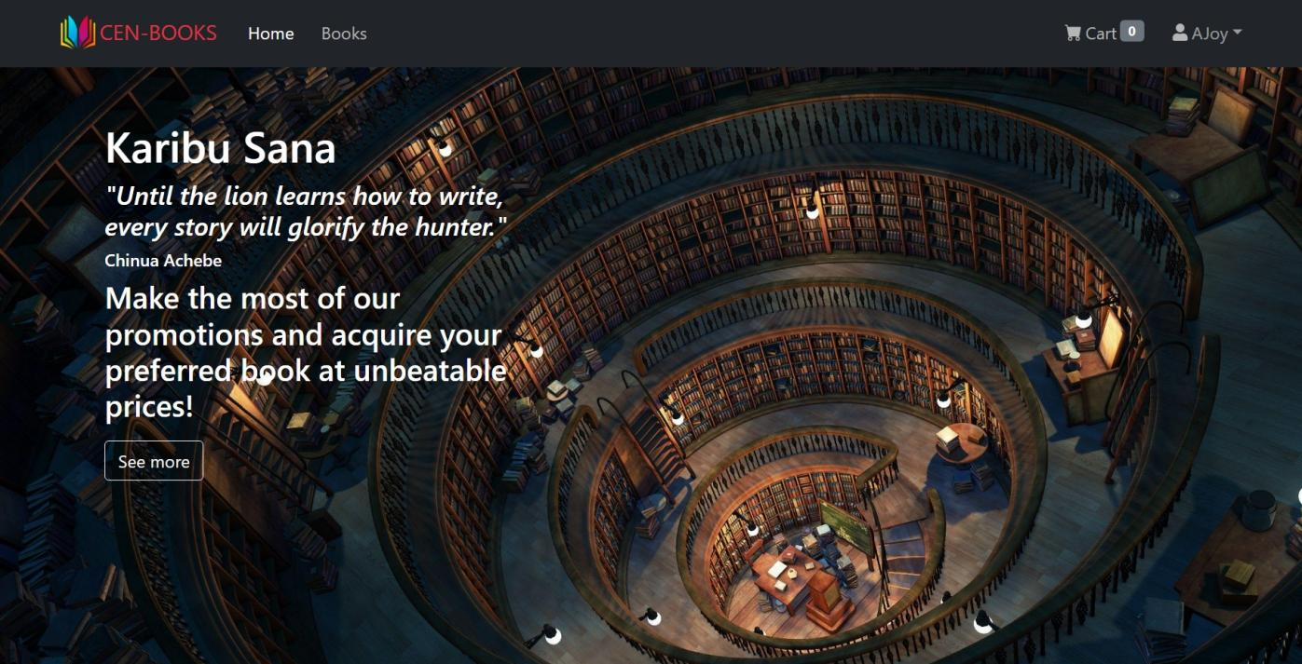

*Navbar and footer*

**

**

*Register and login forms:*

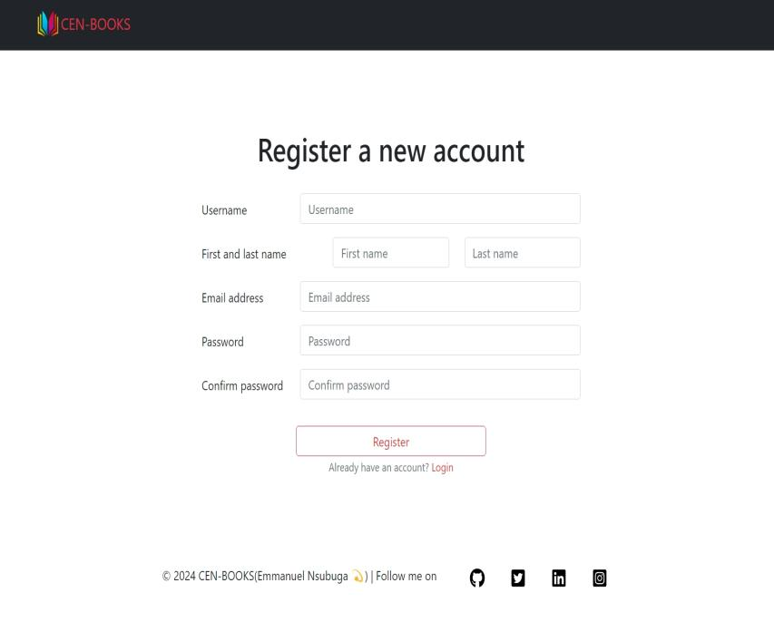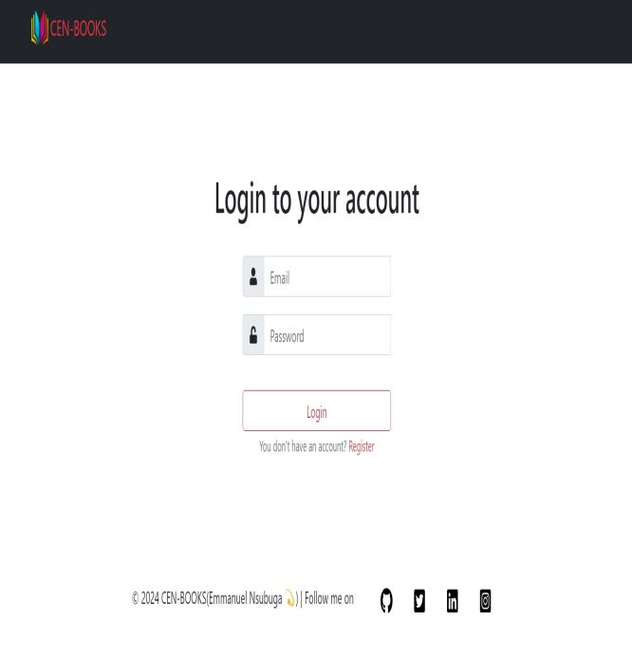

*Profile details &Edit profile information:*

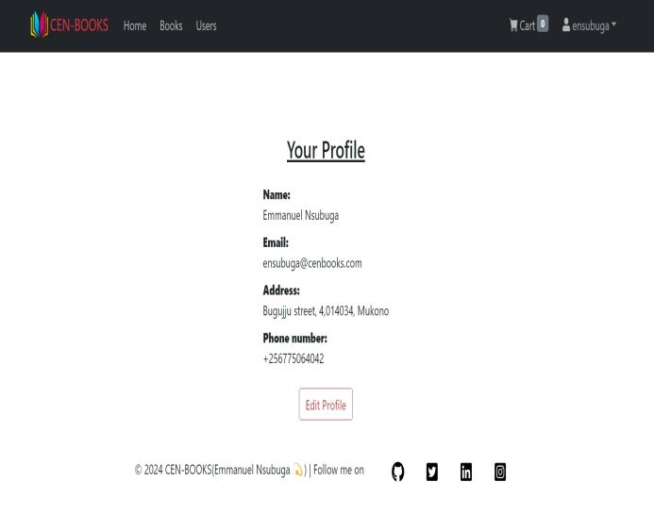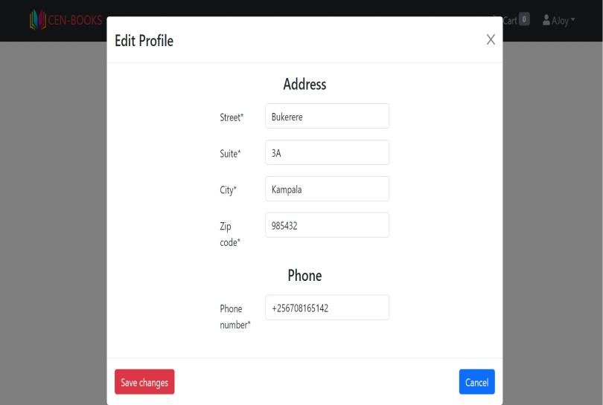

*Books and book-search:*

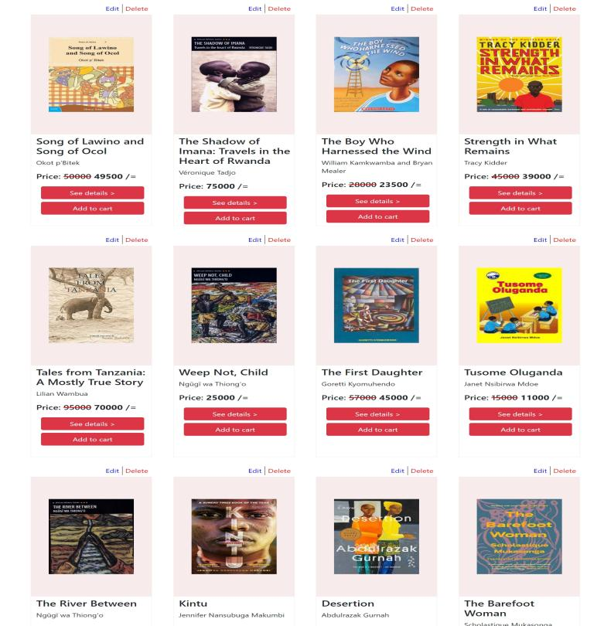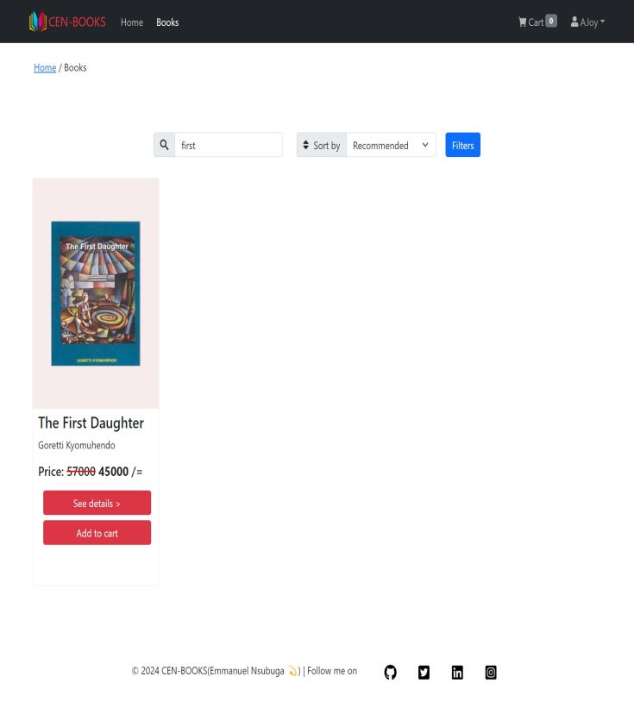

*Filters and Book-details:*

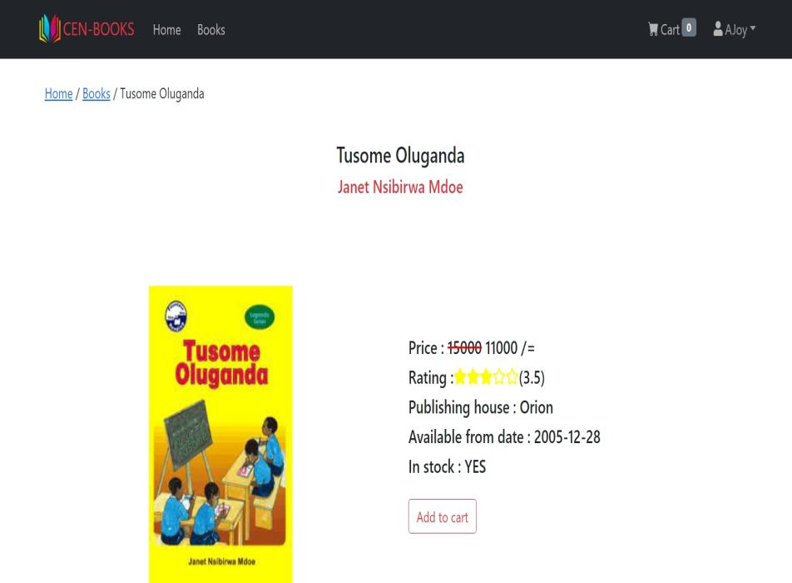

*Cart:*

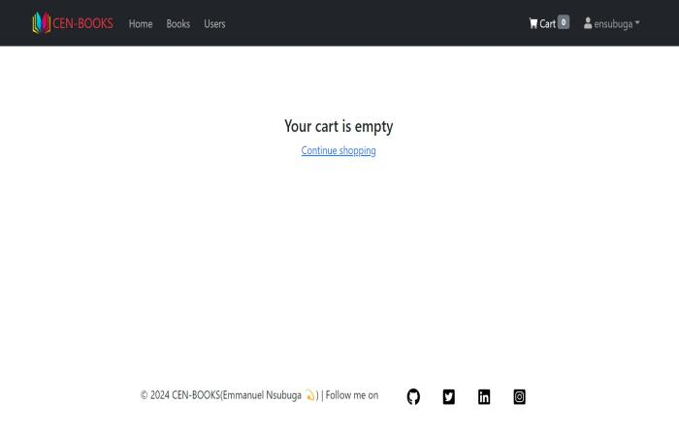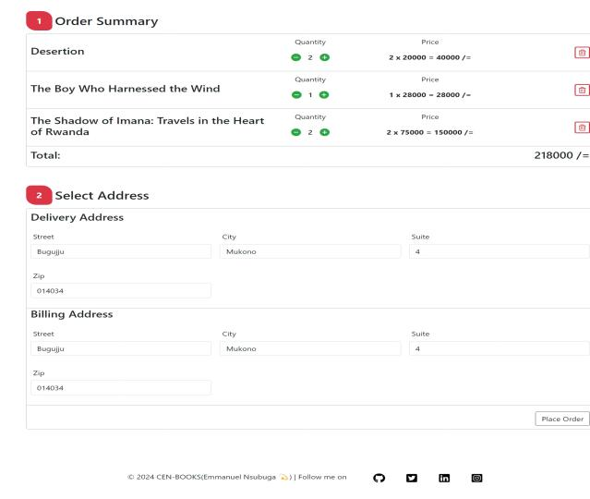

*Home-navbar drop-down*

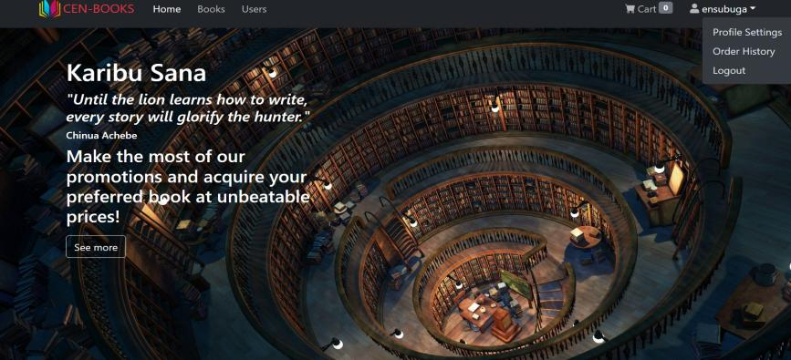

*Order-History:*

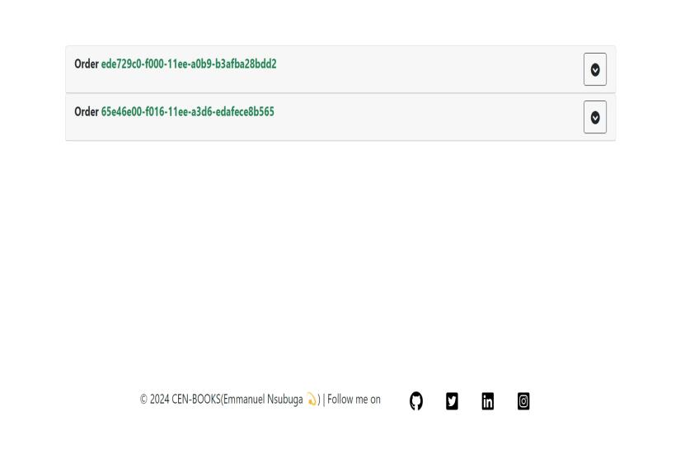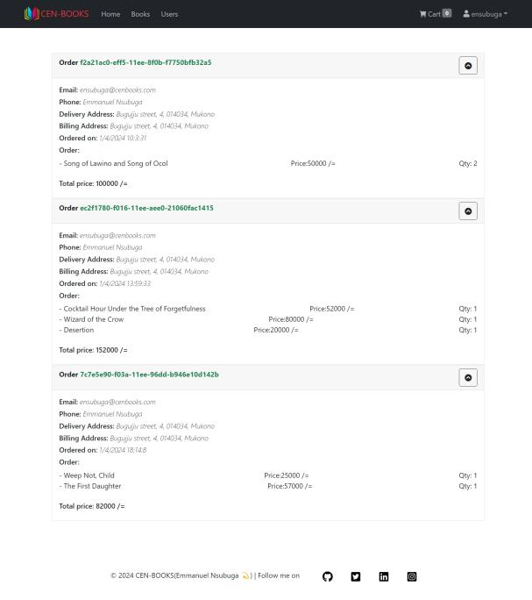

7.1.2 *Admin Interface:*

*Homepage:*

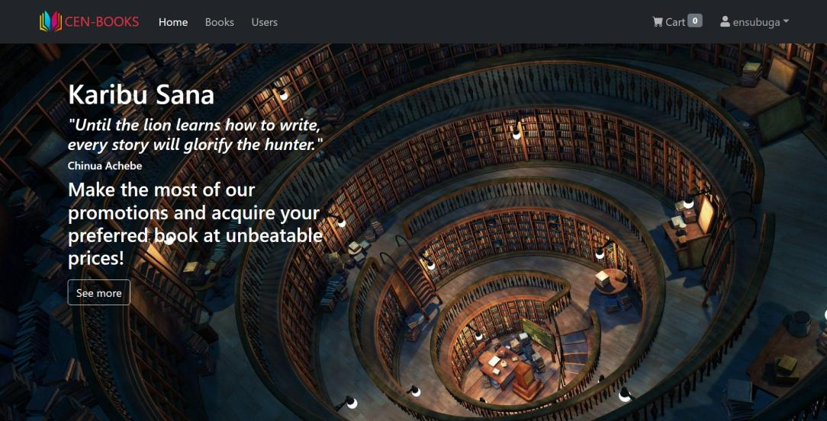

*Users:*

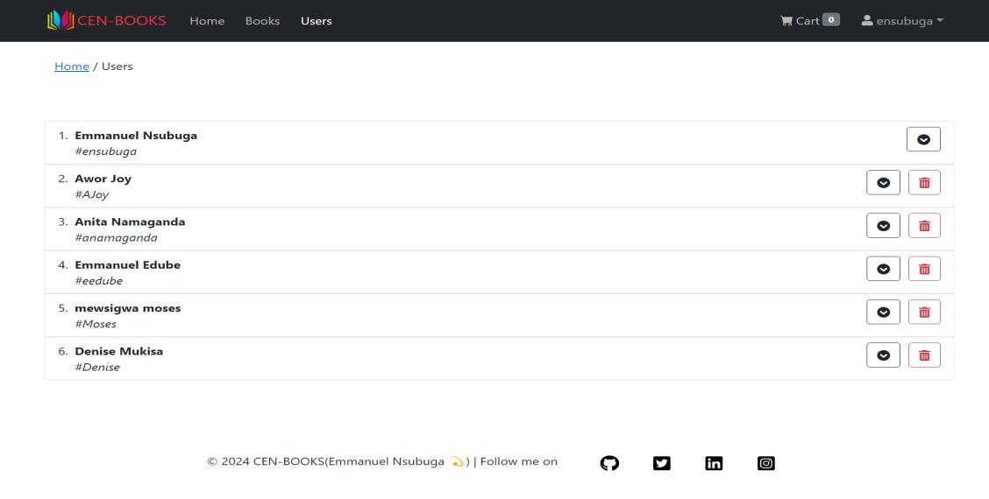

*Books and deleting a book:*

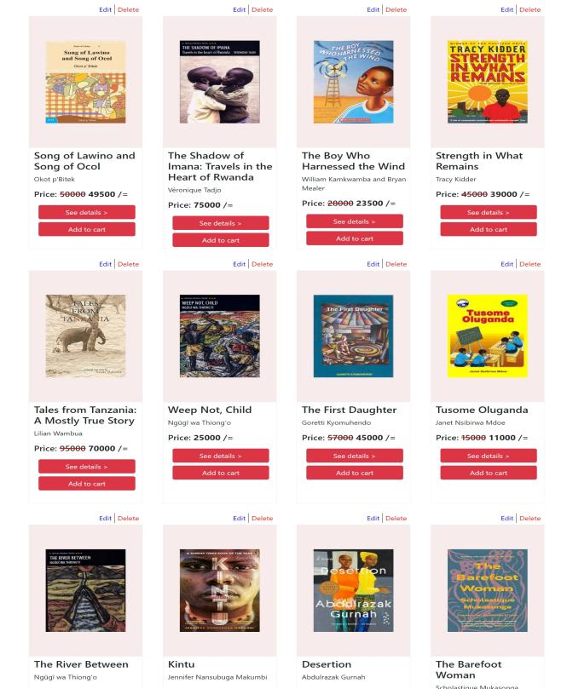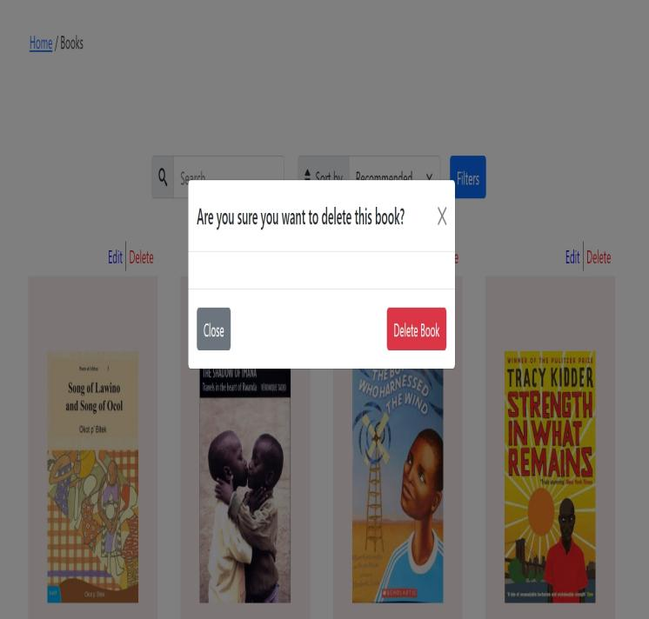

Add a book:

